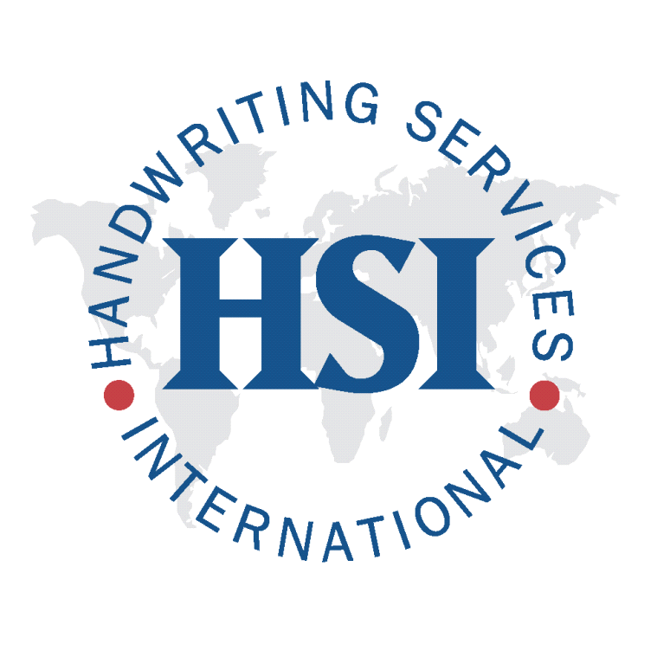

Handwriting Services International
Robert Baier
Forensic Document Examiner
24 Regent Rd. Warwick, NY USA 10990
Bus. 1.888.460.3828 Fax. 845.988.9780
www.expertdocumentexaminerweb.com

CURRICULUM VITAE

Areas of Training
- Examination of Numerous Documents and Cases
- Anonymous Writings
- Handwriting Identification and Comparison
- Altered Numbers
- Disguised Writing
- Document Alteration
- Preparation of Documents for Court
- Court Procedures
- Discrimination and Identification of Writing
- Discriminating Elements of Writing
- Typewriter Identification
- Word Processing Systems

Education
- Dean College; Mass.
Associate of Science Degree in Physical Education
- University of Bridgeport; Bridgeport, Conn.
Bachelor of Science Degree in Physical Education
- Montclair State College; Montclair, N.J.
Master of Arts Degree in Physical Education
- School of Forensic Document Examination (2003-2005)
- School of Forensic Document Examination Conference: Dallas, TX. (10/15-17/04)
- School of Forensic Document Examination Conference: Dallas, TX. (10/14-16/05)

Continuing Education
- American Institute of Applied Science (AIAS) for Questioned Document Examination (2005)
- Mid-Atlantic Association of Forensic Scientists (MAAFS), Pittsburgh, PA, “Questioned Documents Workshop”, training by Jeffrey Bell, Claudine Riggio, and Richard Vorder Bruegge, Image Analysis Unit, FBI Laboratory (5/18/05)
- School of Forensic Document Examination Conference: Dallas, TX. (10/12-15/06)
- Mid-Atlantic Association of Forensic Scientists (MAAFS), Richmond, VA, “Questioned Documents Workshop”, training by Jerry LaPorte U.S. Secret Service Laboratory and Troy Eberhardt from the Immigration and Customs Enforcement, Forensic Document Laboratory “Security Printing and Inks” (5/3/06)
- National Association of Document Examination (NADE) Tucson, AR, (5/15-21/07)
- Forensic Photography
- Art and Artefact Forgery Identification

Curriculum Vitae of Robert Baier Page 2

Continuing Education cont.
- Decoding Identifying Printer Information
- Paper Analysis for Document Examiners
- Extreme Grips
- Solid Ink Printers
- Working with the Media
- Book Smarts for the Document Examiner Featuring the QDE Index
- Introduction to Print Process
- Identification for Forensic Document Examiners
- Forgery Science an Interactive Workshop
- The Metropolitan Police Institute Miami-Dade County, FLA., “Forensic Digital Imaging Enhancement Workshop” 40 hours (6/18-22/07).
- Forensic Document Examiners, Inc. Workshop and Seminar by Katherine Koppenhaver and Bill Koppenhaver (2007, 2008, 2012).
- Apex, North Carolina Town Facility in “Statement Analysis Interviewing Techniques” by Mr. Mark McClish U.S. Marshall (10/1/07).
- National Association of Document Examination (NADE) Boca Raton, FL. (4/22-26/09)
- National Association of Document Examination (NADE) Portland, OR, (5/3-5/7/10)
- National Association of Document Examination (NADE) Montreal, CA (5/17-5/21/11)
- National Association of Document Examination (NADE) San Diego, CA (4/25-4/29/12)
- National Association of Document Examination (NADE) Omaha, NE (4/25-4/27/13)
- Scientific Association of Forensic Examiners (SAFE) Edgewood, MD (9/26-9/28/13)
- Scientific Association of Forensic Examiners (SAFE) Edgewood, MD (8/13-8/17/14)
- International Association of Document Examiners (IADE) Montego Bay, Jamaica (9/10-12/15)
- Scientific Association of Forensic Examiners (SAFE) Online (7/29/16)
- International Association of Document Examiners (IADE) Annapolis, MD (9/15-17/16)

Apprenticeship
- Apprenticeship training under, Mr. Don Lehew, Mrs. Katherine Koppenhaver (2003-2006).

Memberships
- International Association of Document Examiners (IADE)
- New York State Sheriffs’ Association (Honorary Member)
- Scientific Association of Forensic Experts (SAFE)

Forensic Lab Equipment
- Numerous measuring devices and grids
- Variety of magnification equipment
- Hand held magnifiers
- Magnifying portable lamp
- Bausch and Lomb Stereo Microscope 7X – 30X
- Trinocular Stereo Zoom Microscope With Boom Stand - SZSTL2 7X – 45X
- Micronta Illuminated Microscope 8X – 30X
- Celestron Handheld Digital Microscope and Camera 10X – 40X and 150X
- Magnifying Camera OC 185
- Testrite CS-2 Copy Stand with Lights
- Kodak Z740 Digital Camera
- Polaroid Digital Camera Equipment
- Sony Digital Camera
- Special Lighting

Curriculum Vitae of Robert Baier Page 3

Lab Equipment cont.
- Boreal Laboratories Light Filters
- JB4347 Lighted Stand Magnifier
- Light Box by Artograph
- LDP LLC UV Light
- Raytech Ultraviolet Lamp Model LS-4CB Longwave/Shortwave
- Alvin 8 inch navigation dividers
- Starrett Micrometer No.436-1IN
- Dell Optiplex 9020 Computer
- Dell 19 Inch Flat Screen Monitor
- Brother Intellifax 2820
- Dell 962 Scanner; Copier; Printer
- Epson Stylus 595 Scanner; Copier; Printer
- Hewlett Packard 570 Scanner; Copier; Printer; Lazer Printer

Published Books
- “Identity Theft – Prevention for the College Student” by Robert Baier
- “GPS for Success” by Robert Baier, Steven Covey, Dr. John Gray, Les Brown

Library
- All About Pencils by Ann Kessler
- Attorney’s Guide to Document Examination by Katherine Koppenhaver
- The Business of Document Examination Second Edition by Katherine Koppenhaver
- Crime and Penmanship by Ted Widmer
- Document Examiner Textbook by Jess E. Dines
- Detecting Forgery by Joe Nickell
- Developments in Handwriting and Signature Identification in the Digital Age by Heidi H. Harralson
- Evaluating Evidence by Katherine Koppenhaver
- Evidential Documents by James Conway
- Expert Witness Manual by Jess E. Dines
- Forensic Handwriting Examination by Reed Hayes
- Forensic Handwriting Identification: Fundamental Concepts and Principles by Ron Morris
- Fundamentals of Document Examination by Edna W. Robertson
- Handwriting Identification: Facts and Fundamentals by Roy A Huber
- Hidden Evidence by David Owen
- Introduction to Handwriting Examination and Identification by Russell R. Bradford and Ralph B. Bradford
- Law of disputed and Forged Documents by Newton Baker
- Pen, Ink and Evidence by Joe Nickell
- The Printer by Ted Widmer
- Questioned Documents Second Edition by Albert S Osborn
- The Questioned Document Examiner and the Justice System by Dr. Ray Walker
- Red Flags On Forged Checks by Joe Lucas FDE
- Scientific Examination of Questioned Documents Revised Edition by Ordway Hilton
- Suspect Documents: Their Scientific Examination by Wilson R Harrison

March 2018

