Virginia L. Rhodes, Ed.D.  SCHOOL WITNESS | Cincinnati, OH • (513) 207-2566  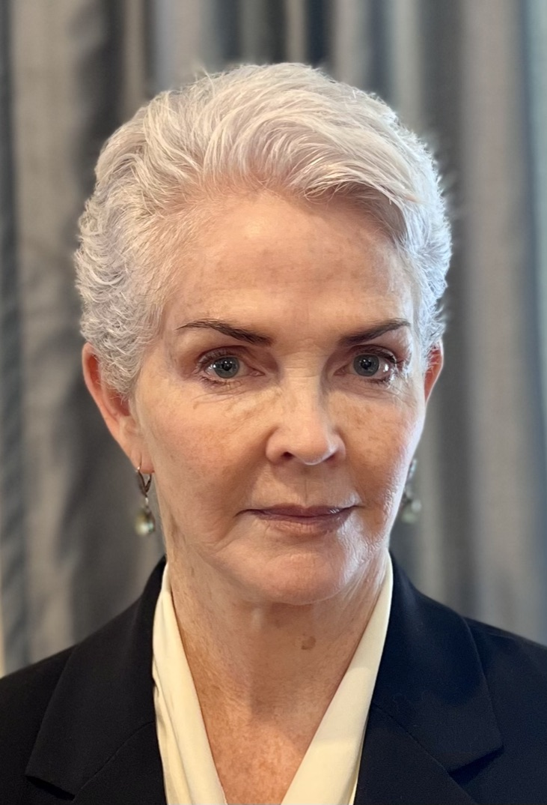  renegadelearning.com  vrhodes2020@gmail.com  /

Attorneys & Firms: Expert witness and consultation services in school-related cases:

EXPERT QUALIFICATIONS
Thirty-five years of experience in 3 key elements of K-12 school district work: teaching, administration, and policymaking. Keen insight, timely reports & compelling testimony for attorneys with school-related court cases. Service to both plaintiff & defense since 2009.
I work with a wide range of issues in K-12 schooling: Failure to serve (protected class), accident/injury/death of students, security & safety procedures, discipline (excessive force), wrongful termination, abuse (physical or sexual) by staff or peers, professional error, safety measures, discrimination (gender, race, religion, disability), failure of training & supervision, class action, effects on underfunding on local schools, and whistleblower retaliation. With attorneys in domestic court cases, I evaluate and school enrollment options for their divorcing/separating clients.

My K-12 career journey, which I enjoyed immensely, enables me to give thoughtful and detailed insight to attorneys whose work involves intricate issues of policy, procedure, and practice. I have the skills to dissect incidents in these areas, measuring duty and standard of care in the context of policy and professional expectations. I can provide clarity into the daily workings of districts and schools....and distinguish between best practices, common practices and unacceptable practices in teaching, administration, and policymaking.
How is my work different than other educational consultants or experts? I simplify complex educational matters into plain language that judges and lay juries will understand. I bring a research, policy, and practice orientation, and provide appropriate basis for my opinions. My reports are clear and timely. I come to deposition and court fully prepared. I'm respectful and compelling on the stand, and I don't get rattled.

Through this insight, analysis and testimony, districts affected by litigation are able to use hindsight to improve their systems and daily practices. Districts that work with me directly as a consultant have the advantage of these learnings before their safety nets fail and a lawsuit is filed.
During previous cases, I have consistently delivered well-researched and credible work that has illuminated the issues at hand. My reputation for being convincing and credible precedes me, and I am confident that my expertise can contribute to your firm's success in handling cases from small stakes to high-profile ones.
Attorney Bob Klingler's comments on our work together in a federal case illustrates my value to your case:
Virginia Rhodes provided expert witness testimony for me in a complex and difficult case involving public school policy and a disabled teacher. Dr. Rhodes was incredibly thorough, insightful, and quick to grasp the issues. At her deposition, I just sat back and let her handle herself, which she did with aplomb. Her involvement was instrumental to our success in the case. Moreover, she is a pleasure to work with. I can’t recommend her highly enough.

Robert A. Klingler, Klingler Law, Cincinnati, OH

An initial call to establish fit is always without charge.
Virginia L. Rhodes, Ed.D.
Call 513-207-2566 or email http://vrhodes2020@gmail.com for CV, Case List and Fee Agreement

