Experts in Weather
WeatherNet provides legal weather reports, expert analysis and interpretation to the legal profession and all those involved in criminal or civil litigation.
Our comprehensive archive of UK weather data, unrivalled meteorological knowledge and experience, ensures that our evidence is robust, authoritative and accurate.
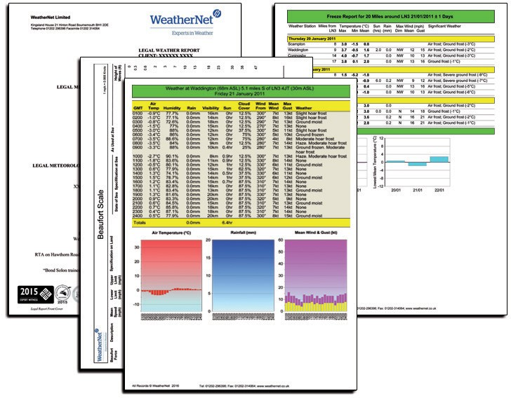

WeatherNet legal weather reports, certified witness statements and expert witness convey information in an understandable way and in a format that complies with civil and criminal court requirements.

Legal (CPR) weather reports and certified witness statements for use in court if required. Please email or call Dr Richard Wild for current prices.
Legal (non CPR) weather reports for reference only. Please email or call Dr Richard Wild for current prices.
Forensic meteorologist available for providing testimony in court anywhere in the UK.
Since 1997 we have prepared in excess of 2000 legal weather reports on cases of:
- Personal Injury Claims
(Falling, Tripping and Slipping Accidents)
- Road Traffic Accidents (RTAs)
- Domestic and Commercial Insurance Claims
- Travel and Transit
- Civil Engineering and Construction Disputes
- Contract Disputes
- Criminal Offences (GBH, Rape, Murder and Burglary)
- Flooding and Drainage Claims
- Aviation and Marine Incidents
- Pollution and Contamination
- Lighting, Visibility and Sunset/Sunrise Times
- Industrial and Agricultural Incidents
- Sports and Leisure Injuries

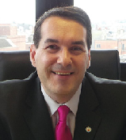Further Information
Dr Richard Wild BSc (Hons) PhD FRMetS FRGS MAE MCSFS

Senior Forensic Meteorologist
Dr Wild has been a professional meteorologist for 20 years and heads our legal team.
He is a regular contributor to radio, TV and press. Fellow of the Royal Meteorological Society (FRMetS), Fellow of the Royal Geographical Society (FRGS), Member of the National Geographic Society, Research Leader of the Tornado and Storm Research Organisation (TORRO), Member of the Academy of Experts (MAE), Professional Member of the Chartered Society of Forensic Sciences (MCSFS), Member of the Association of British Climatologists, ‘APIL expert’ of the Association of Personal Injury Lawyers and Member of the Thomson Reuters Expert Witness Services. Additionally, Dr Wild is ‘trained in the aspects of report writing’ and the ‘Jackson Reforms’ by Bond Solon and is included on the NCA (National Crime Agency) Expert Advisers Database.

WEATHER SERVICES
to the LEGAL PROFESSION

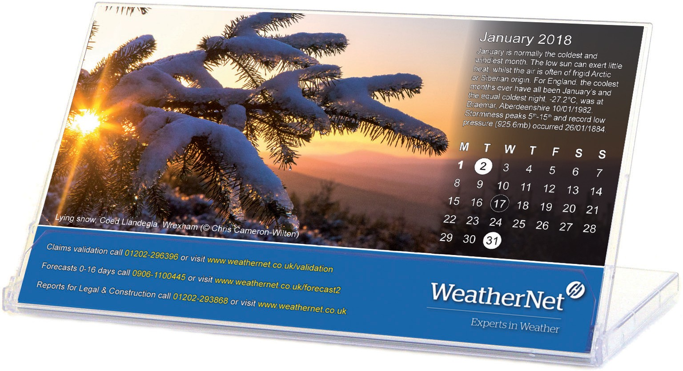WeatherNet provides online weather applications,
data sets, reports, consultancy and advice.
- Insurance Claims Validation
- Downtime and NEC Reports for Construction
- Legal Weather Reports and Certified Witness Statements
- Weather Sensitivity Analyses and Demand Modelling
- Weather Forecasts and Weather Warnings
Obtain your copy
of the WeatherNet calendar by sending your details to rick@weathernet.co.uk
or call us on 01202 293867

“Dr. Wild delivered a thorough forensic report well within agreed timescales. This report brought about a change in tactics from the other side so that on appeal the same issues regarding the weather were not pursued”.
Gaynor Sutton
Nicholas Sutton Solicitors
“Dr Richard Wild can be relied on for a solid report for our defence cases defining the position at a particular time and place. The clarity and structure of the WeatherNet report allows me to make informed recommendations to clients”.
Tara McSorley
BLM
“I have always found Dr Wild’s reports to be comprehensive, intelligible and readily accepted by the Courts. His reports have been more than decisive on more than one occasion, which, in fraud litigation, is relatively rare. I would recommend WeatherNet without hesitation”.
Sunil Nannar
DWF LLP

